Class Time:
Names:

Normal Distribution: Normal Distribution Lab I
Student Learning Outcome:
- The student will compare and contrast empirical data and a theoretical distribution to determine if Terry Vogel's lap times fit a continuous distribution.
Note: Round the relative frequencies and probabilities to 4 decimal places. Carry all other decimal answers to 2 places.
Collect the Data
- Use the data from Terri Vogel’s Log Book. (Look in the Table of Contents Appenaix Data Sets) Use a Stratified Sampling Method by Lap (Races 1 – 20) and a random number generator to pick 6 lap times from each stratum. Record the lap times below for Laps 2 – 7.

- Construct a histogram. Make 5 - 6 intervals. Sketch the graph using a ruler and pencil. Scale the axes.
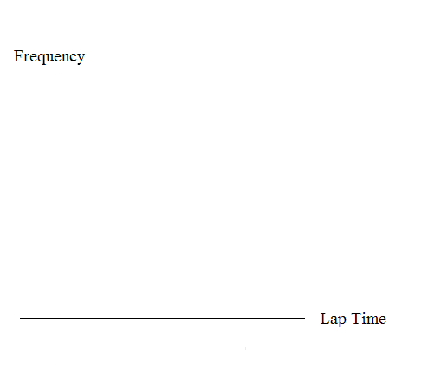
3. Calculate the following
  - = _______
  - s = _______
4. Draw a smooth curve through the tops of the bars of the histogram. Use 1– 2 complete sentences to describe the general shape of the curve. (Keep it simple. Does the graph go straight across, does it have a V shape, does it have a hump in the middle or at either end, etc.?)

Analyze the Distribution
Using your sample mean, sample standard deviation, and histogram to help, what was the approximate theoretical distribution of the data from “Collect the Data?”
- X ~ ____________
- How does the histogram help you arrive at the approximate distribution?
Describe the Data
Using the data in “Collect the Data” (Hint: order the data):
Remember: IQR = Q3 – Q1
- The IQR goes from _______ to ______.
- IQR = _______.
- The 15th percentile is ________.
- The 85th percentile is _______.
- The median is _______.
- The empirical probability that a randomly chosen lap time is more than 130 seconds = _______.
- Explain the meaning of the 85th percentile of this data.

Theoretical Distribution
Using the theoretical distribution in “Analyze the Distribution”:
- The IQR goes from _______ to _______.
- IQR = _______.
- The 15th percentile is _______.
- The 85th percentile is _______.
- The median is _______.
- The probability that a randomly chosen lap time is more than 130 seconds = _______.
- Explain the meaning of the 85th percentile of this distribution.

Discussion Questions
Do the data from “Collect the data” give a close approximation to the theoretical distribution in “Analyze the Data?” In complete sentences and comparing the results in “Describe the Data” and “Theoretical Distribution”, explain why or why not.

